|  |
| --- |
|  |
|  |
| **DESIGNER User Manual**  **---------------**  Automated Test with the Robot |

|  |
| --- |
| **Designer User Manual** |

Contents

Foreword 4

Working with Proxy 5

Login 7

User Interface 7

User interface for the editing 8

User Interface 8

Control Panel 9

User Interface 9

Scenario 10

User Interface 10

Scenario Edit 11

Scenario Import 12

Test 13

Test Edit 18

Import Test 20

Logfile 21

Gallery 22

Suite Set 23

User Interface 23

Suite Set Edit 24

Logfile 25

Gallery 26

Story Set 27

Story set 27

Story set Edit 28

Stories 29

Stories Edit 30

Logfile 31

Gallery 32

Reference 33

Reference 33

Reference Edit 34

Export Reference 35

Import Reference 36

Dictionary 37

Dictionary set 37

Dictionary set Edit 38

Dictionary word 39

Dictionary word Edit 40

Dictionary unused word 41

Rules 42

Rules set 42

Rules set Edit 43

Rules 44

Rules Edit 45

Import rule set (including rules) 46

Loop 47

Principle 47

Break a loop 48

End of a loop 49

Examples of loop 50

Performance 52

Principle 52

Define the measure 53

Mechanism 54

Performance with the Robot 56

Performance with Admin right 60

Example of graphs of performance designed in Excel 61

**Foreword**

This user manual will give you information on how to use the robot as a Designer.

**Designer:**

The Designer is responsible for:

* The design of the Scenarios
* The design of the Suites
* The design of the Stories
* The management of the References
* The management of the Dictionary
* The design of the Rules

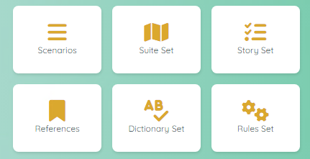

# **Working with Proxy**

If you need to test a project that requires a proxy, please use the following method.

**Job to be performed by the Administrator:**

In the parameters of the project, create a new entry for the parameter Proxy

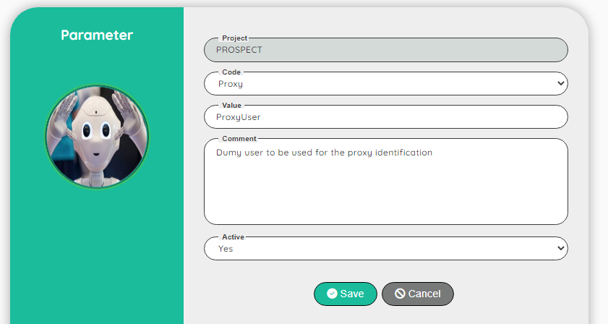

The value must be a valid dummy user

**Job to be performed by the Tester (or Designer, Administrator):**

Go to the dummy users and add a new entry for the value defined in the parameter (here: ProxyUser)

In the field Extra information, fill the proxy link including the port number

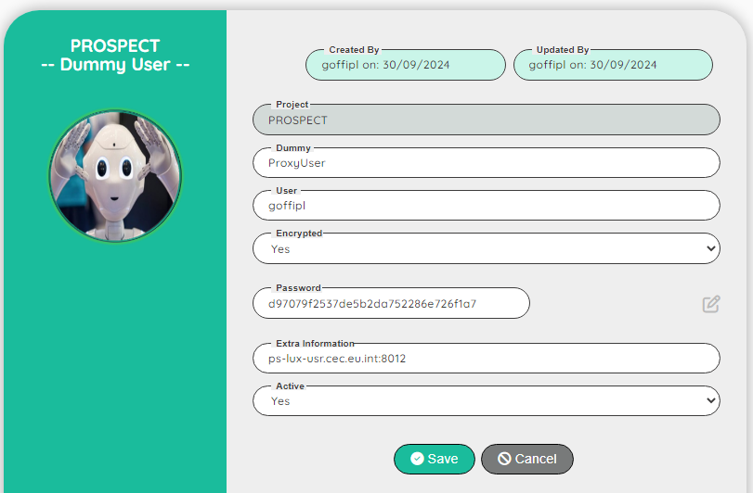

Note: You can encrypt the password

If you don’t need a proxy login, you don’t need to define a specific parameter and dummy user.

If you try to connect to a proxy website without defining the parameter and the dummy user, the application will display a window to ask you to enter a proxy login/password.  
This popup window cannot be manipulated by normal functions!

If you define a proxy, the Robot will be able to login to a normal website or a website with proxy.  
For information: the time to launch the script will be shorter with a proxy defined!

# **Login**

|  |
| --- |
| User Interface |

To access to the Robot, you need to have a login.  
After you successfully register to the application as a new user (Guess), you have to wait that the Administrator will assign you a Role to a project (or multiple projects).

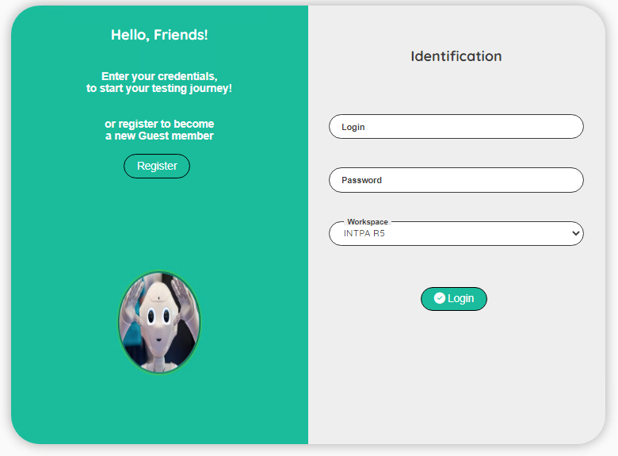

| **Topic** | **Icon** | **Comment** |
| --- | --- | --- |
| Register |  | Click to Register as a new user |
| Login |  | Enter your login |
| Password |  | Enter your password |
| Workspace |  | Enter your workspace |
| Login |  | Click to login to the Robot |

# **User interface for the editing**

|  |
| --- |
| User Interface |

We use the same user interface when editing a record.  
To avoid repeating the same explanation all the time, you will find here a generic explanation on how to use the edit interface.  
When you have the permission to edit a record, you will see the following icons:  


| **Topic** | **Icon** | **Comment** |
| --- | --- | --- |
| Delete | or | Delete a record (a confirmation is required!) To delete multiple records, select the records first. |
| Edit |  | Go to a screen to update the record. |
| Copy |  | First select the record to copy and then click on the copy icon. Record(s) will be set after the copy icon. |
| Move |  | First select the record to move and then click on the move icon. Record(s) will be set after the move icon. |
| Select / Unselect | / | Select or unselect a record |

Depending of the context, some extra icon(s) can be available.  
The extra icon(s) will be explain in the section dedicated to the context.

# **Control Panel**

|  |
| --- |
| User Interface |

The dashboard will allow you to execute pre-defined stories.  
If you are assign to a **DESIGNER** or **ADMIN** role, your user interface will look like this:

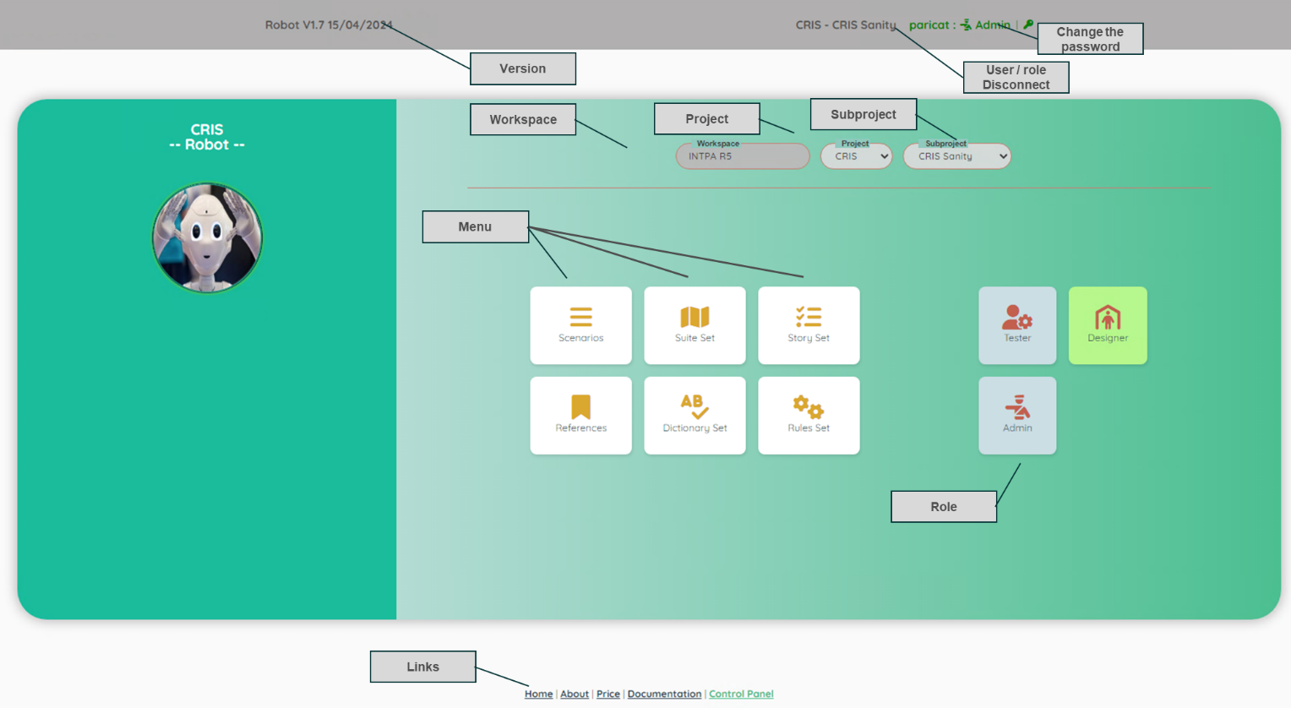

| **Topic** | **Comment** |
| --- | --- |
| Version | Version of the Robot. |
| Workspace | For info: the name of the workspace of the customer. |
| Project | List of the project(s) that you have access (assignment to a project is done by an Administrator). |
| Subproject | Access to all the subproject(s) of the selected project. |
|  | When executing a story, you can stop the execution. |
| User/Role Disconnect | For info: your login and your role. If you click on the ‘User/Role’, you will be disconnected from the application. |
| Change the password | Click on the icon to change your current password |
| Menu | Click on the items to open a new section of the application |
| Links | Useful links |

# **Scenario**

|  |
| --- |
| User Interface |

The Scenario will allow you to manage the scenarios and the tests

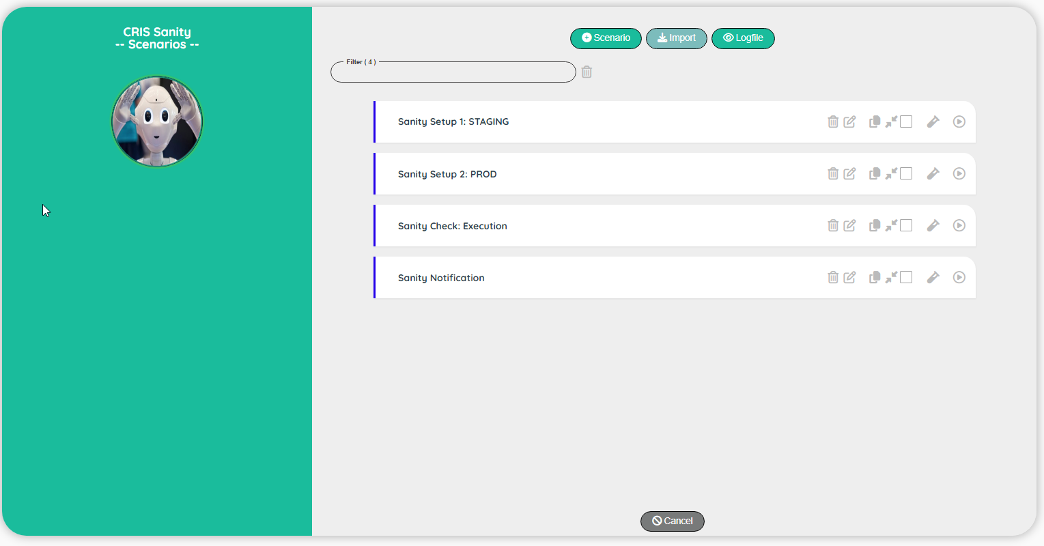

| **Topic** | **Icon** | **Comment** |
| --- | --- | --- |
| Test |  | Go to the screen Test. |
| Execute |  | Execute a scenario. |
| Add Scenario |  | Add a new scenario at the end of the list. |
| Cancel |  | Back to the Dashboard screen. |
| Logfile |  | Go to the screen to view the Log file. |
| Import |  | Import a scenario from any project (same workspace). |

Note: if you click on the comment, you will see extra information  
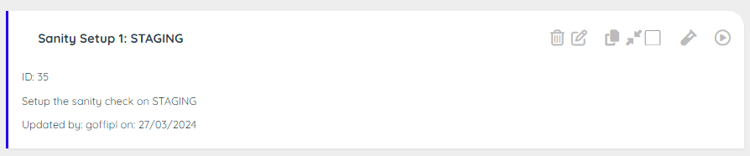

|  |
| --- |
| Scenario Edit |

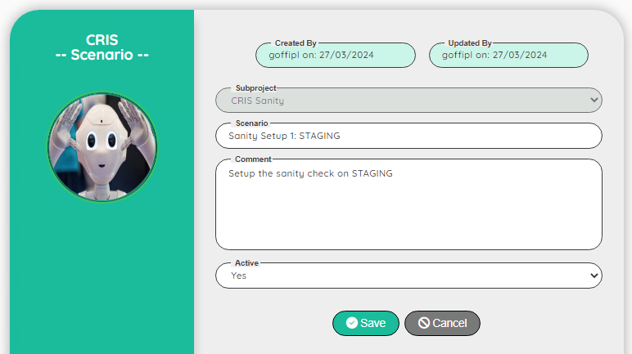

| **Topic** | **Icon** | **Comment** |
| --- | --- | --- |
| Subproject |  | For info: Name of the subproject |
| Scenario |  | Name of the scenario |
| Comment |  | Comment on the scenario |
| Active |  | Yes, No |
| Save |  | Save the edit |
| Cancel |  | Discard the edit |

|  |
| --- |
| Scenario Import |

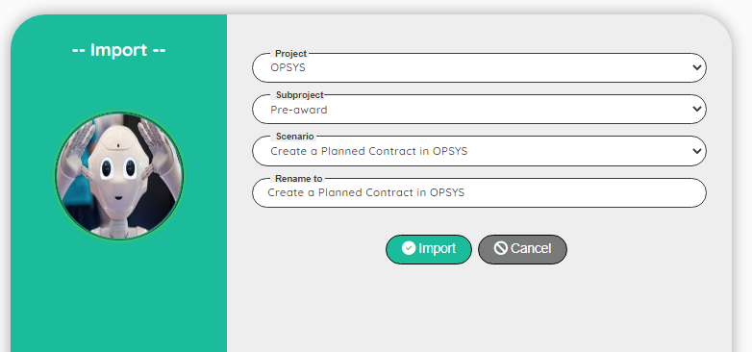

| **Topic** | **Icon** | **Comment** |
| --- | --- | --- |
| Project |  | Select a project in the list |
| Subproject |  | Select a subproject in the list |
| Scenario |  | Select a scenario to import |
| Rename |  | You can update the name if necessary |
| Import |  | Import the scenario |
| Cancel |  | Discard the import |

|  |
| --- |
| Test |

The Test will allow you to manage the tests (steps)

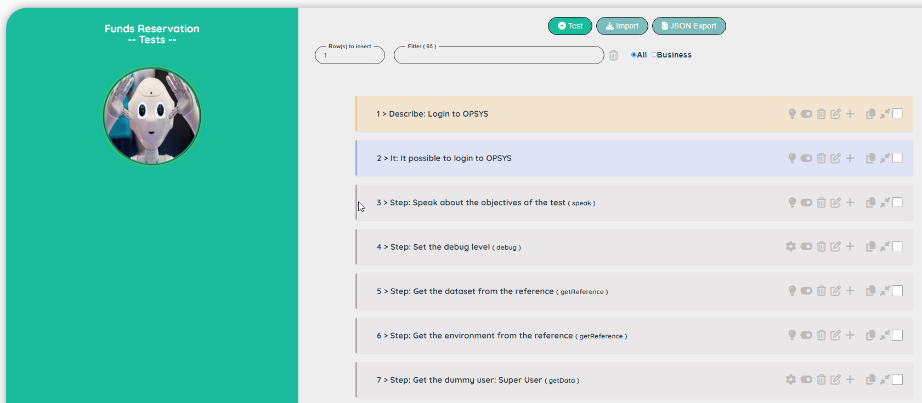

| **Topic** | **Icon** | **Comment** |
| --- | --- | --- |
| All / Business |  | Display all comments or only the ones for the Business |
| Add Test |  | Add a new test at the beginning of the list. |
| Active/Inactive |  | Set the test Inactive/Active |
| Business/Designer |  | Set the comment type to Business / Designer (Technical) |
| Cancel |  | Back to the Dashboard screen. |
| Import |  | Import a test(s) from another scenario (but in the same project) |
| JSON Export |  | Export the current test(s) into a .json file |
| Download |  | Click on the link to download the .json file |

Note: if you click on the comment, you will see extra information

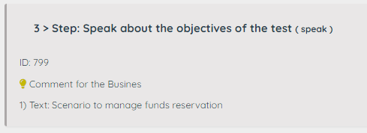

### How to process the .json file into Excel

### Open a blank Excel workbook

* Go to the ‘Data’ section and click on ‘Get Data’

* Select the option ‘From JSON’

* Select the .json file from the folder ‘Download’ on your local driver.  
  a new window is now opened.  
  Click in the item of the menu ‘Into Table Convert’

* Click on the right icon of the cell Value and select Expand to New rows

Click again on the right icon of the cell Value and click OK

The data are now displayed into a table.  
Click the first item in the menu ‘Close & Load’

And now, you have a nice table with the tests of a scenario.

You can now manage this table to share with the Business Team.  
For instance, you can remove the name of the function and the parameters and eventually, remove the technical test (like wait a little bit or wait for the refresh of the screen…)

|  |
| --- |
| Test Edit |

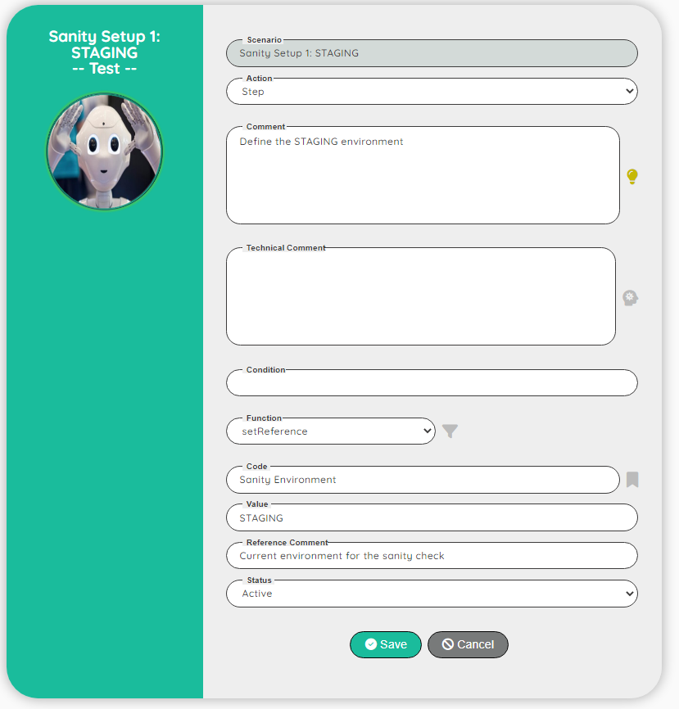

| **Topic** | **Icon** | **Comment** |
| --- | --- | --- |
| Scenario |  | For info: Name of the scenario |
| Comment | Comment for the Business  Comment for the Designer | Comment on the test |
| Technical |  | Text used for the natural language process |
| Condition |  | Any valid JavaScript expression. If the condition is false the test will be skipped! |
| Function | / | Select the name of the function (you can also filter by name or comment) |
| Parameters |  | Parameters depending of the selected function |
| Active |  | Yes, No |
| Save |  | Save the edit |
| Cancel |  | Discard the edit |

**Note:** The comment can be defined as a text for the Business or for the Designer (more technical).  
This is a simple way to indicate to the Business that want to review the scenario which steps are useful for him.  
During the export, the field ‘commentType’ will be exported with the values:

* 1: Comment for the Business
* 0: Comment for the Designer (technical)

|  |
| --- |
| Import Test |

The Import Test will allow you to import a test from another scenario (but from the same project).

First select a scenario

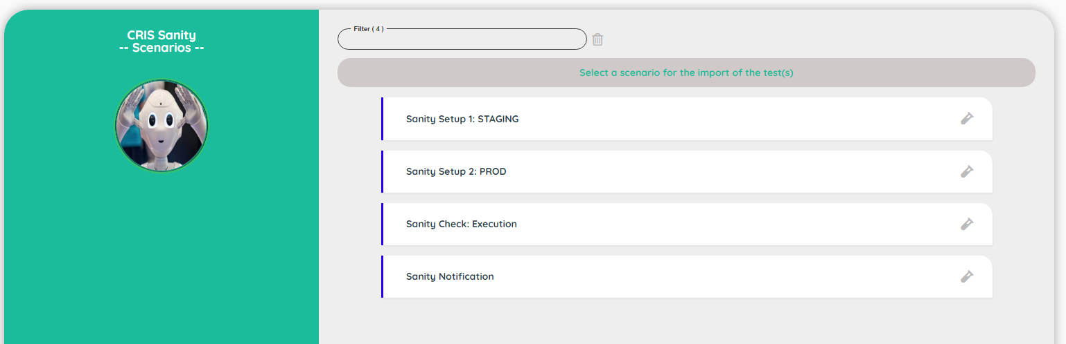

Select the test(s) that you want to import

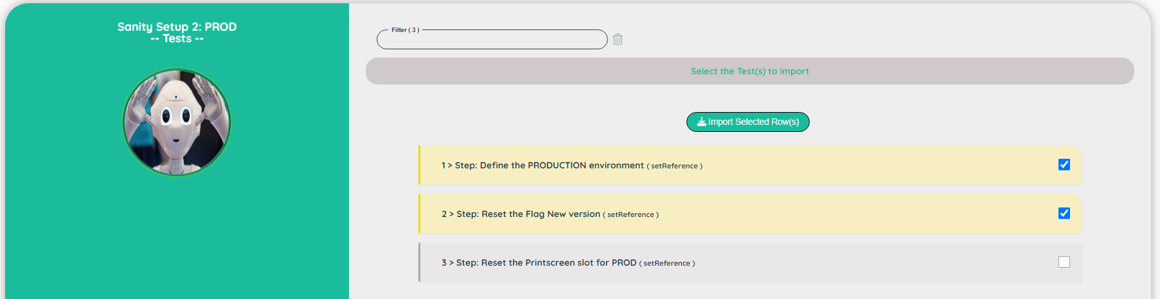

Click on the button 

|  |
| --- |
| Logfile |

The logfile will show you all the steps executed with extra information.  
It helps you to understand how the test has been executed.  
Note: There is one logfile by user. You see always the logfile of the last execution

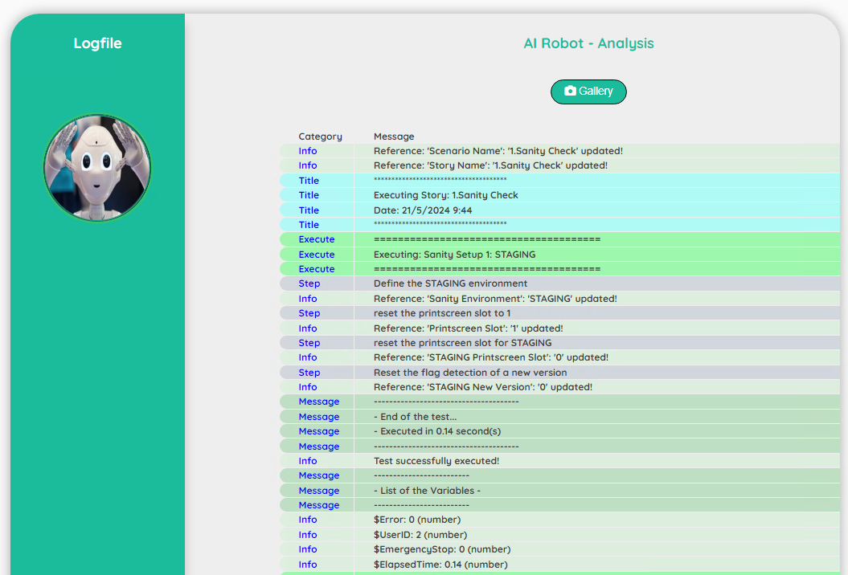

| **Topic** | **Icon** | **Comment** |
| --- | --- | --- |
| Gallery |  | Access to the print screen(s) |

|  |
| --- |
| Gallery |

The gallery will show you the print screen taken during the execution of the story.  
The first print screen is done automatically by the Robot when an error occurs (it will show you the last error detected – in case of success of a story, you will see the last error detected)

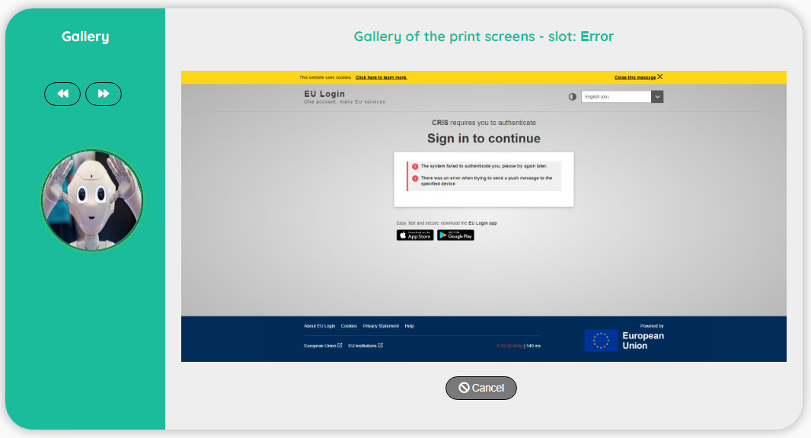

| **Topic** | **Icon** | **Comment** |
| --- | --- | --- |
| Previous |  | Go to the previous print screen |
| Next |  | Go to the next print screen |
| Cancel |  | Back to the Logfile |

# **Suite Set**

|  |
| --- |
| User Interface |

The Suite will allow you to group different scenarios (you can also consult the best practices guide for more information about the suite). A suite is composed from a suite set (parent) and suites (children)

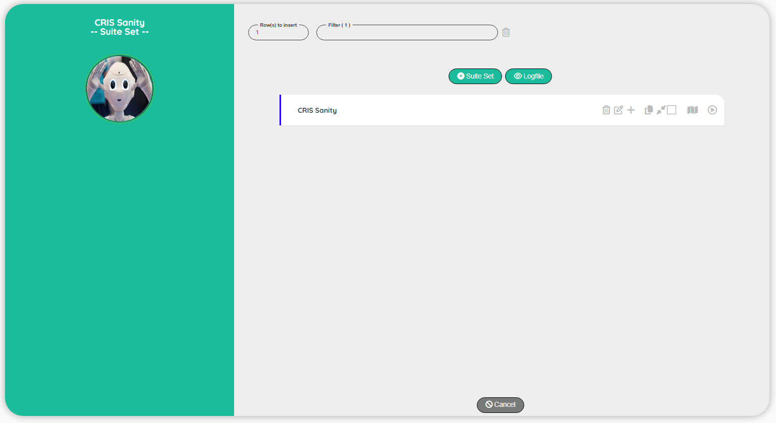

| **Topic** | **Icon** | **Comment** |
| --- | --- | --- |
| Suite |  | Go to the screen suite |
| Execute |  | Execute a suite. |
| Add Suite set |  | Add a new Suite at the beginning of the list. |
| Cancel |  | Back to the Dashboard screen. |
| Logfile |  | Go to the screen to view the Log file. |

|  |
| --- |
| Suite Set Edit |

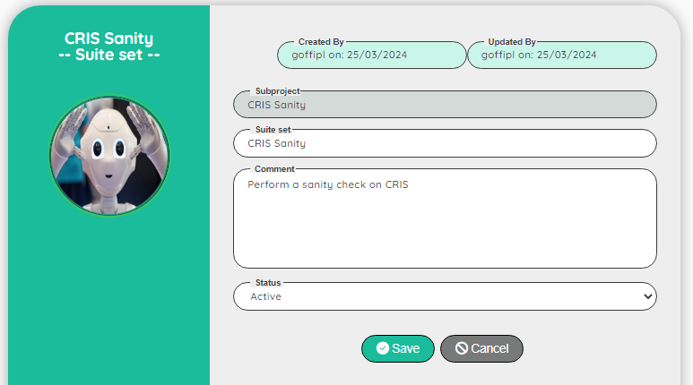

| **Topic** | **Icon** | **Comment** |
| --- | --- | --- |
| Subproject |  | For info: Name of the subproject |
| Suite set |  | Name of the suite set |
| Comment |  | Comment for the suite set |
| Active |  | Yes, No |
| Save |  | Save the edit |
| Cancel |  | Discard the edit |

|  |
| --- |
| Logfile |

The logfile will show you all the steps executed with extra information.  
It helps you to understand how the test has been executed.  
Note: There is one logfile by user. You see always the logfile of the last execution



| **Topic** | **Icon** | **Comment** |
| --- | --- | --- |
| Gallery |  | Access to the print screen(s) |

|  |
| --- |
| Gallery |

The gallery will show you the print screen taken during the execution of the story.  
The first print screen is done automatically by the Robot when an error occurs (it will show you the last error detected – in case of success of a story, you will see the last error detected)



| **Topic** | **Icon** | **Comment** |
| --- | --- | --- |
| Previous |  | Go to the previous print screen |
| Next |  | Go to the next print screen |
| Cancel |  | Back to the Logfile |

# **Story Set**

|  |
| --- |
| Story set |

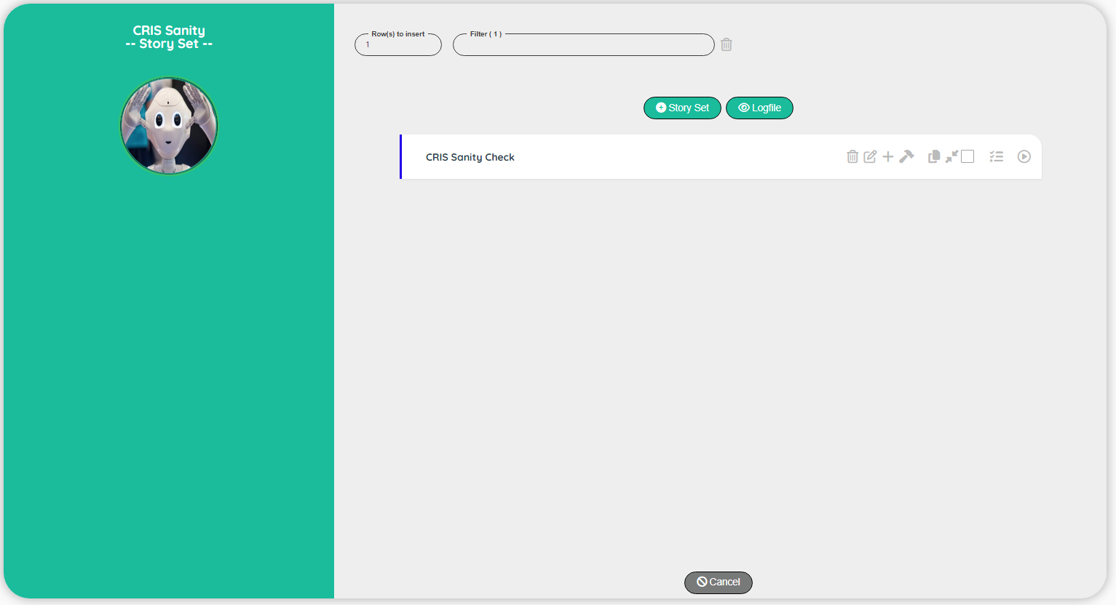

| **Topic** | **Icon** | **Comment** |
| --- | --- | --- |
| Stories |  | Go to the screen Stories. |
| Execute |  | Execute a Story. |
| Parameters |  | Add a story at the beginning of the list |
| Add Story |  | Add a story at the beginning of the list |
| Cancel |  | Back to the control panel |
| Logfile |  | Go to the screen to view the Log file. |

|  |
| --- |
| Story set Edit |

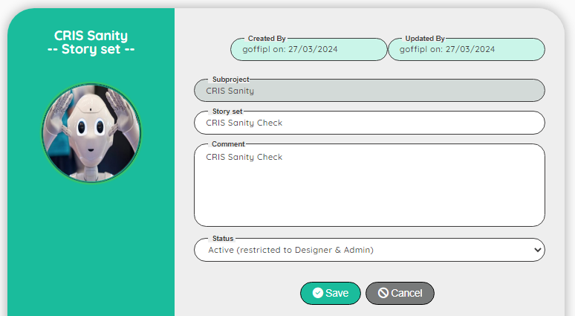

| **Topic** | **Icon** | **Comment** |
| --- | --- | --- |
| Subproject |  | For info: Name of the subproject |
| Story set |  | Name of the story set |
| Comment |  | Comment for the story set |
| Active |  | Active, Not active, Publish |
| Save |  | Save the edit |
| Cancel |  | Discard the edit |

**Note:** The Tester can see only the Published story (Active and Published are visible by the Designer and the Administrator)

|  |
| --- |
| Stories |

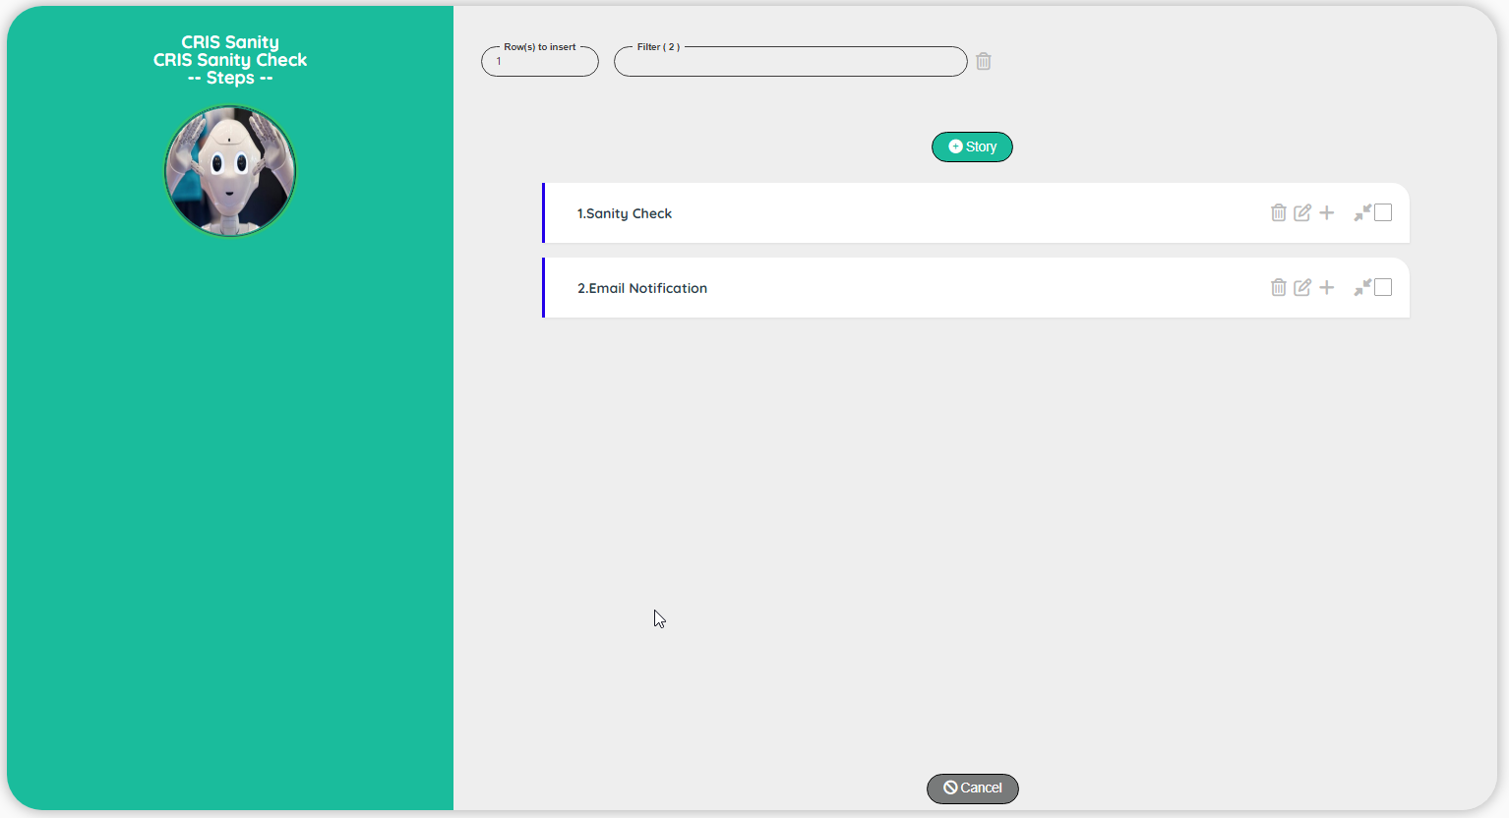

| **Topic** | **Icon** | **Comment** |
| --- | --- | --- |
| Add Story |  | Add a story at the beginning of the list |
| Cancel |  | Back to the Story set |

|  |
| --- |
| Stories Edit |

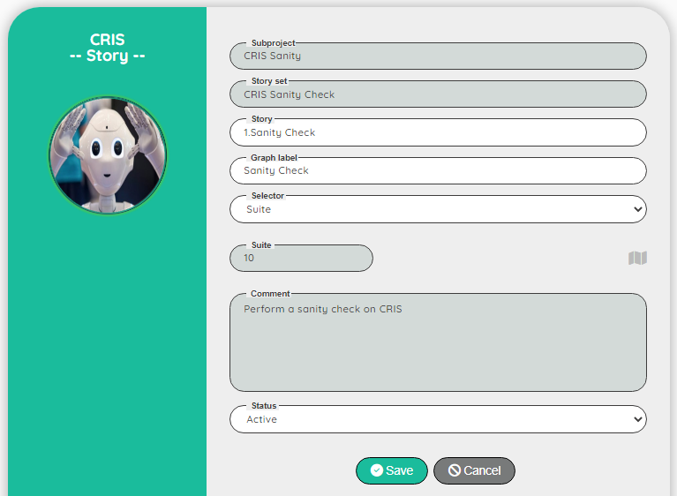

| **Topic** | **Icon** | **Comment** |
| --- | --- | --- |
| Subproject |  | For info: Name of the subproject |
| Story set |  | For info: Name of the story set |
| Story |  | Name of the story |
| Graph label |  | Scenario or Suite |
| Selector |  | Comment for the story set |
| Selector Info |  | ID and Comment on the selected selector |
| Active |  | Active, Not active, Publish |
| Save |  | Save the edit |
| Cancel |  | Discard the edit |

|  |
| --- |
| Logfile |

The logfile will show you all the steps executed with extra information.  
It helps you to understand how the test has been executed.  
Note: There is one logfile by user. You see always the logfile of the last execution



| **Topic** | **Icon** | **Comment** |
| --- | --- | --- |
| Gallery |  | Access to the print screen(s) |

|  |
| --- |
| Gallery |

The gallery will show you the print screen taken during the execution of the story.  
The first print screen is done automatically by the Robot when an error occurs (it will show you the last error detected – in case of success of a story, you will see the last error detected)



| **Topic** | **Icon** | **Comment** |
| --- | --- | --- |
| Previous |  | Go to the previous print screen |
| Next |  | Go to the next print screen |
| Cancel |  | Back to the Logfile |

# **Reference**

|  |
| --- |
| Reference |

The reference will show all the values stored by the scenarios in order to exchange data.  
A reference is own by a specific user for a project.

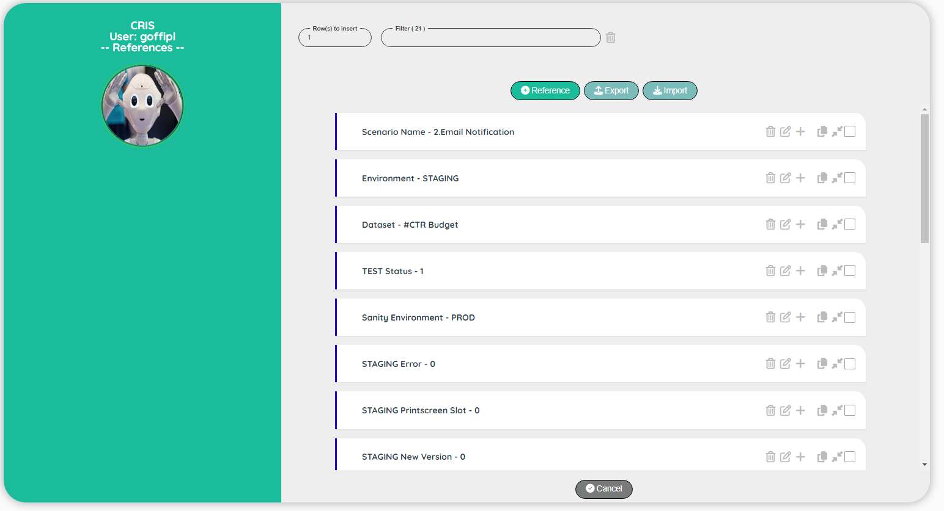

| **Topic** | **Icon** | **Comment** |
| --- | --- | --- |
| Add Reference |  | Add a reference at the beginning of the list. |
| Cancel |  | Back to the control panel. |
| Export |  | Go to the screen to export a reference. |
| Import |  | Go to the screen to import a reference. |

|  |
| --- |
| Reference Edit |

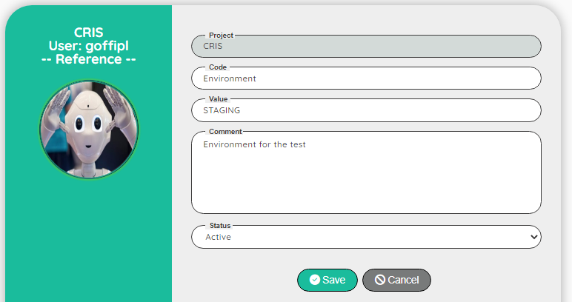

| **Topic** | **Icon** | **Comment** |
| --- | --- | --- |
| Project |  | For info: Name of the project |
| Code |  | Code of the reference |
| Value |  | Value of the reference |
| Comment |  | Comment for the reference |
| Active |  | Active, Not active |
| Save |  | Save the edit |
| Cancel |  | Discard the edit |

**Note:** The reference ‘Environment’ is very important for the tool, be sure to create one and keep the value relevant to your tests (‘Environment’ is used in the Dashboard to display the graph with the performances).  
Example of value for Environment could be for instance: PROD, ACC, TEST, STAGING….

|  |
| --- |
| Export Reference |

The export will allow you to take a backup or to share your reference with another colleague.

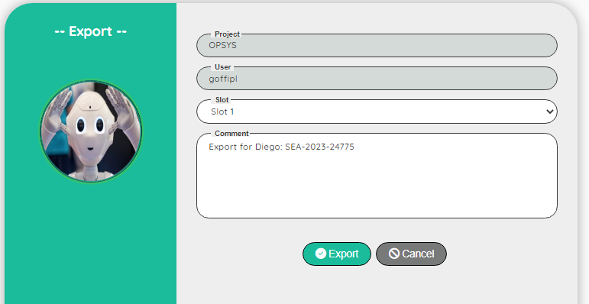

| **Topic** | **Icon** | **Comment** |
| --- | --- | --- |
| Project |  | For info: Name of the project |
| User |  | For info: Login of the user |
| Slot |  | 10 slots are available to back up your references |
| Comment |  | Comment on the export |
| Export |  | Export the references |
| Cancel |  | Back to the control panel. |

|  |
| --- |
| Import Reference |

The import will allow you to restore a backup or get a reference from another colleague.  
Be careful, you current references will be erased and replaced by the import

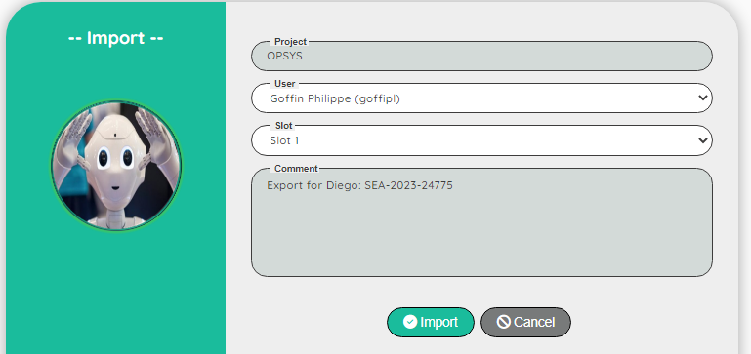

| **Topic** | **Icon** | **Comment** |
| --- | --- | --- |
| Project |  | For info: Name of the project |
| User |  | Select a user in the list |
| Slot |  | Select a slot |
| Comment |  | For info: Comment on the export |
| Import |  | Import the references |
| Cancel |  | Back to the control panel. |

# **Dictionary**

|  |
| --- |
| Dictionary set |

The dictionary is available for a project. It is composed of a dictionary set and a dictionary word.  
You can store URL, xpath or even translation (there is a field language that you can use)  
For the translation, the logic is the following: if you ask for an unknown language, the record with the language ‘*’ will be used. So, you can for instance, use ‘*’ for English and if a translation in another language is missing, the user will receive the English translation.  
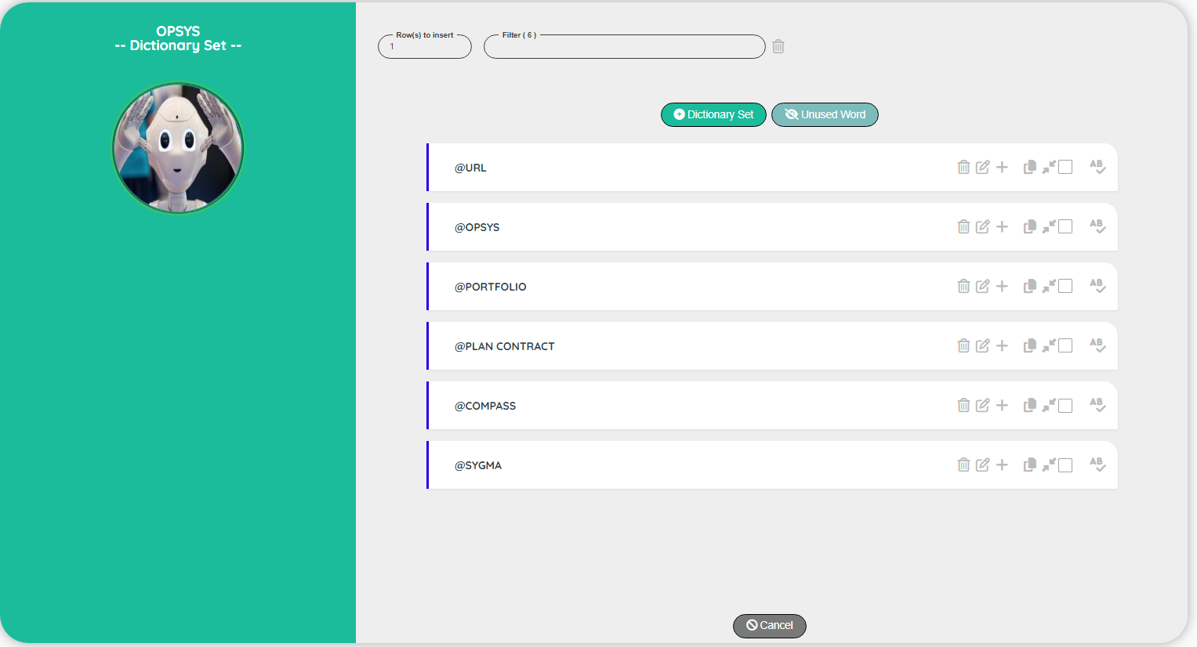

| **Topic** | **Icon** | **Comment** |
| --- | --- | --- |
| Dictionary |  | Go to the screen dictionary word |
| Add Dictionary |  | Add a dictionary set at the beginning of the list. |
| Unused word |  | Go to the screen to export a reference. |
| Cancel |  | Back to the control panel. |

|  |
| --- |
| Dictionary set Edit |

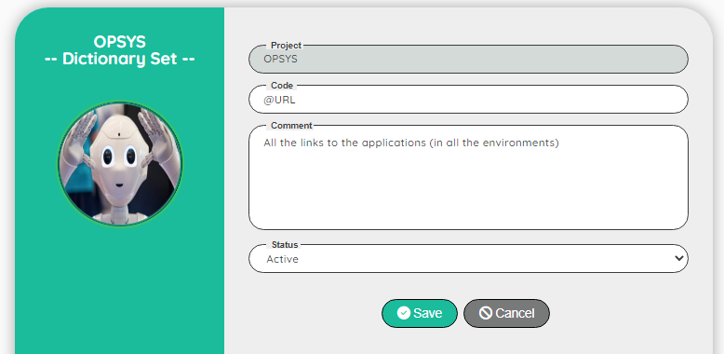

| **Topic** | **Icon** | **Comment** |
| --- | --- | --- |
| Project |  | For info: Name of the project |
| Code |  | Code of the dictionary must start by @ |
| Comment |  | Comment for the dictionary |
| Active |  | Active, Not active |
| Save |  | Save the edit |
| Cancel |  | Discard the edit |

|  |
| --- |
| Dictionary word |

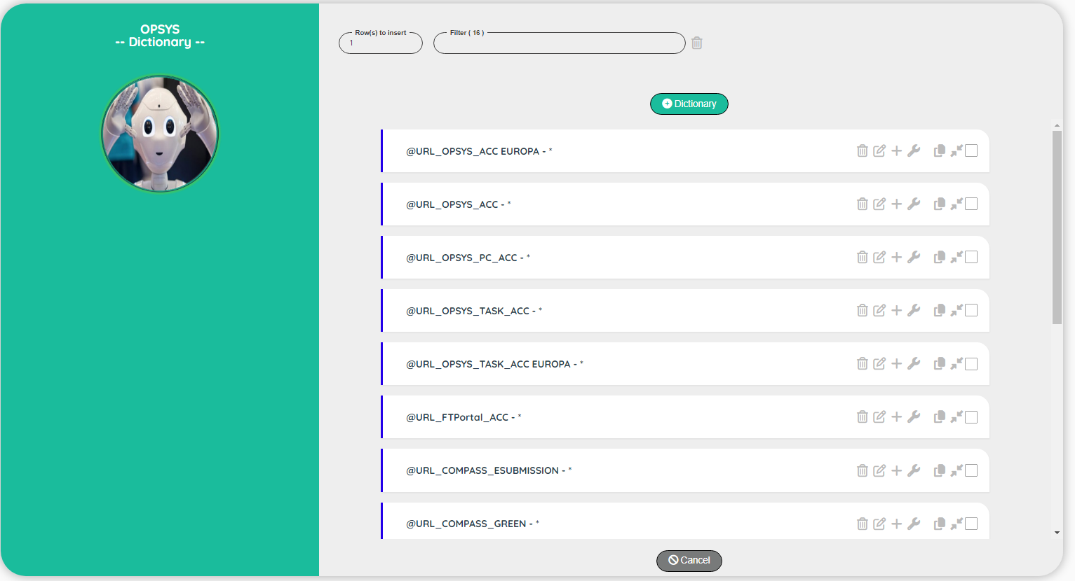

| **Topic** | **Icon** | **Comment** |
| --- | --- | --- |
| Add Dictionary |  | Add a word at the beginning of the list. |
| Cancel |  | Back to the control panel. |

|  |
| --- |
| Dictionary word Edit |

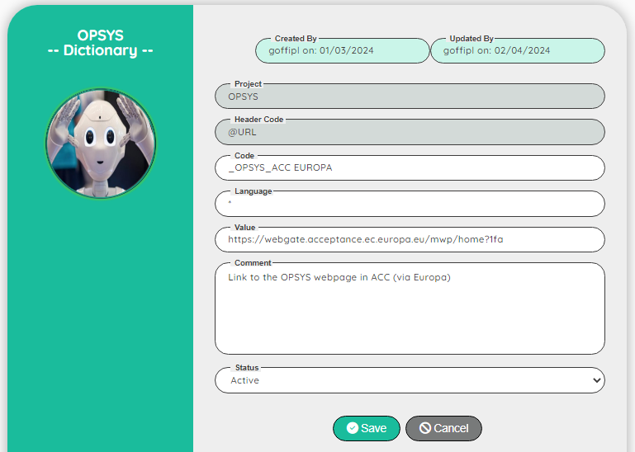

| **Topic** | **Icon** | **Comment** |
| --- | --- | --- |
| Project |  | For info: Name of the project |
| Dictionary set |  | For info: Name of the dictionary set |
| Code |  | Code of the dictionary must start by @ |
| Language |  | * by default, but you can use an ISO code (EN, FR…) |
| Comment |  | Comment for the dictionary word |
| Active |  | Active, Not active |
| Save |  | Save the edit |
| Cancel |  | Discard the edit |

|  |
| --- |
| Dictionary unused word |

This screen will show you all the unused word(s).  
Be careful, the detection can be fooled when you use a variable to replace a partial name of a word. For instance if you have @URL_Acceptance, it will be flagged as unused if you use the following step in your scenario: @URL_$Environment.

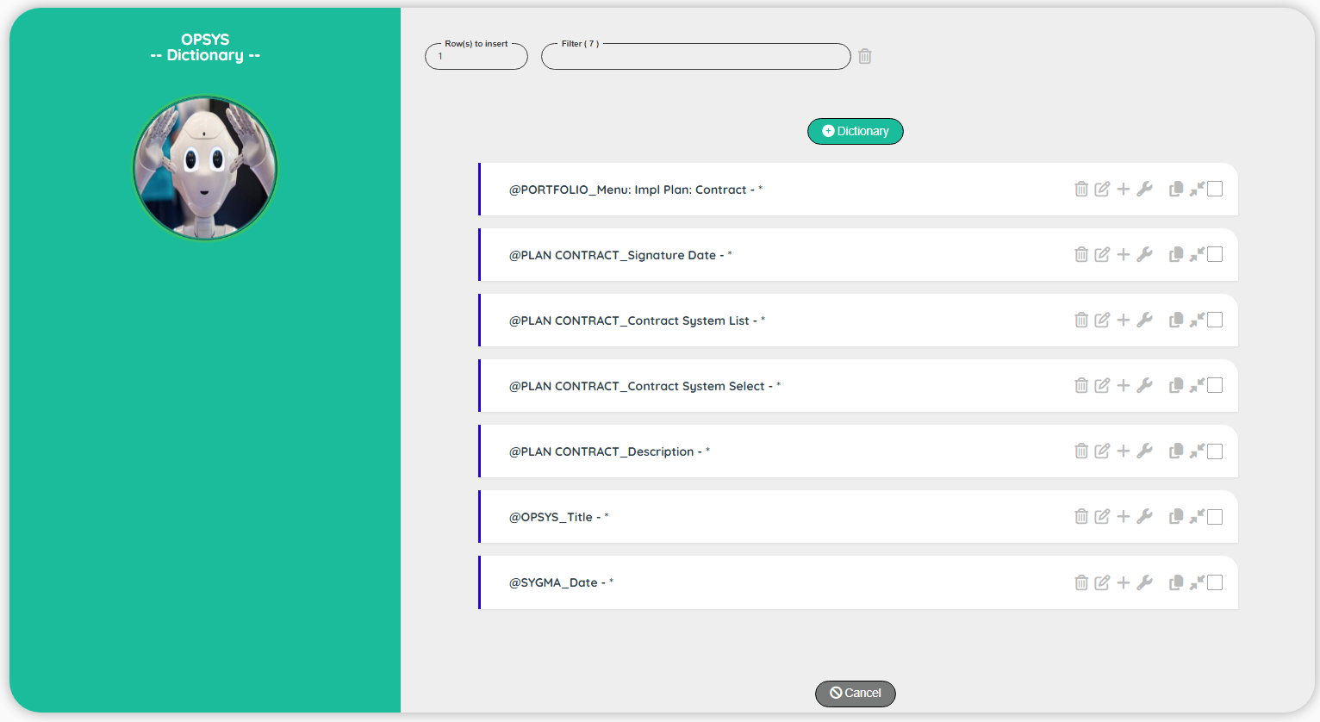

| **Topic** | **Icon** | **Comment** |
| --- | --- | --- |
| Cancel |  | Discard the edit |

# **Rules**

|  |
| --- |
| Rules set |

The rules are available for a project. It is composed of a rule set and rules.  
The rules can be used by the robot to make a decision or by the Designer to define subroutine that can be reused. All the functions are available also in the rules.

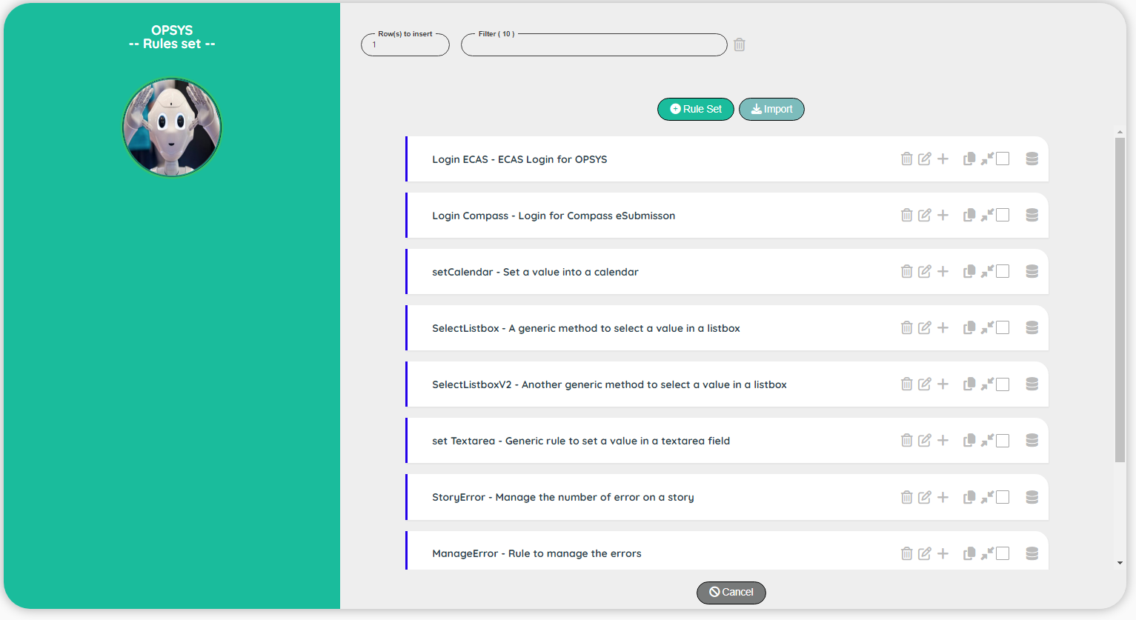

| **Topic** | **Icon** | **Comment** |
| --- | --- | --- |
| Rules |  | Go to the screen Rules |
| Add Rule set |  | Add a rule set at the beginning of the list. |
| Import rules |  | Import rules from another project |
| Cancel |  | Back to the control panel. |

|  |
| --- |
| Rules set Edit |

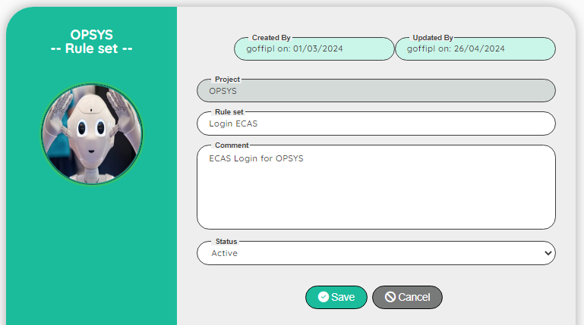

| **Topic** | **Icon** | **Comment** |
| --- | --- | --- |
| Project |  | For info: Name of the project |
| Rule set |  | Code of the rule set |
| Active |  | Active, Not active |
| Save |  | Save the edit |
| Cancel |  | Discard the edit |

|  |
| --- |
| Rules |

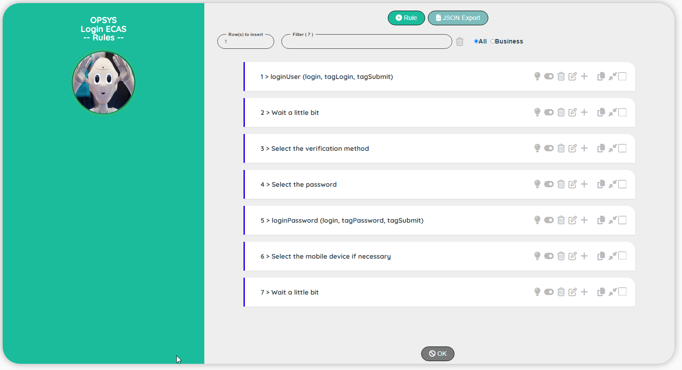

| **Topic** | **Icon** | **Comment** |
| --- | --- | --- |
| Add Rule |  | Add a rule at the beginning of the list. |
| JSON Export |  | Export rules into a .json file |
| Download |  | Download the .json file |
| Active/Inactive |  | Set the test Inactive/Active |
| Business/Designer |  | Set the comment type to Business / Designer (Technical) |
| Cancel |  | Back to the rule set. |

**Note:** To view how to upload a ‘.json’ file into an Excel sheet, please refer to the section: How to process the .json file into Excel

|  |
| --- |
| Rules Edit |

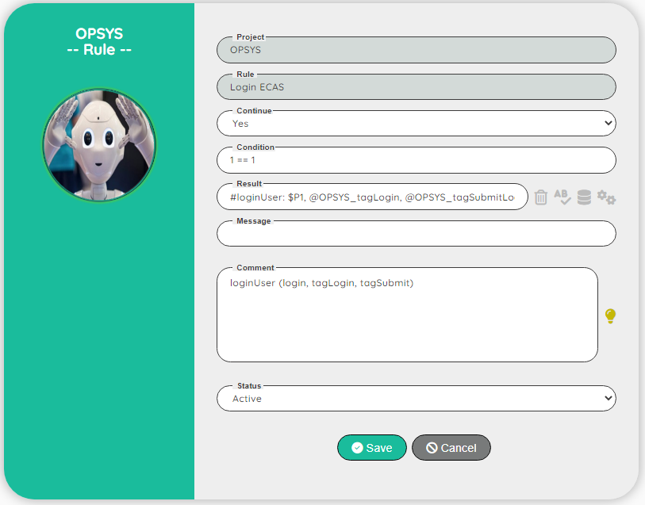

| **Topic** | **Icon** | **Comment** |
| --- | --- | --- |
| Project |  | For info: Name of the project |
| Rule set |  | For info: Name of the rule set |
| Continue |  | Select Yes or Skip |
| Condition |  | Any valid JavaScript expression |
| Result |  | Any valid JavaScript expression or an existing function with its parameters (function starts with #) |
| Comment | Comment for the Business  Comment for the Designer | Comment on the test |
| Active |  | Active, Not active |
| Save |  | Save the edit |
| Cancel |  | Discard the edit |

|  |
| --- |
| Import rule set (including rules) |

This screen will allow you to import the rules from another project

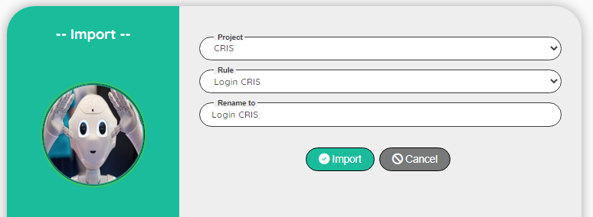

| **Topic** | **Icon** | **Comment** |
| --- | --- | --- |
| Project |  | Select a project |
| Rule set |  | Select a rule |
| Rename to |  | If necessary, rename the rule |
| Import |  | Import the rules |
| Cancel |  | Discard the import |

# **Loop**

|  |
| --- |
| Principle |

The Loops are very useful when you need to repeat a process.  
Example: Upload a set of documents, key a set of experts data…

To define a loop, you need to use the instruction Loop

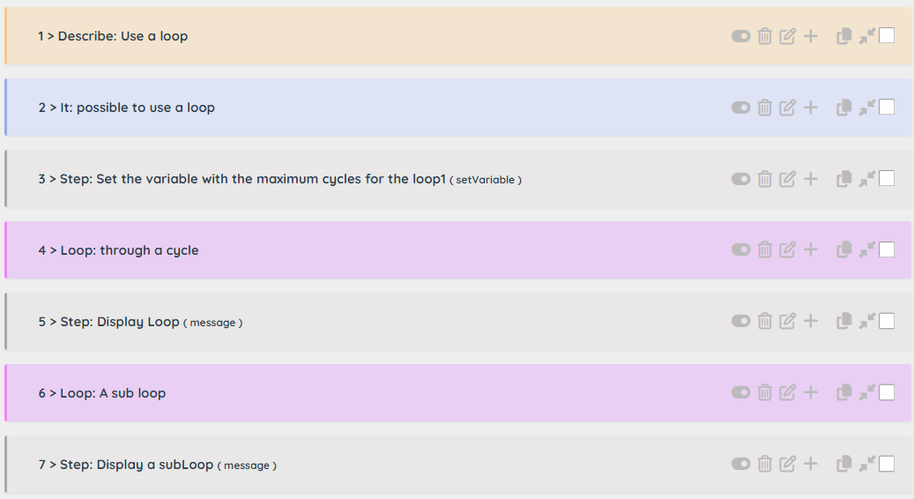

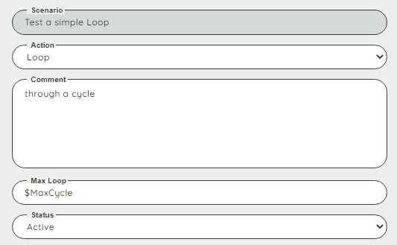

Loop has a parameter: Max Loop to define the number of loops.  
Note: If a ‘It block’ is defined, the loop is inside the block (and so, depends on the condition of a skipIt or a skipDescribe)

You can control the loop thanks to the variable $Loop or $Loop1 (it’s equivalent).  
For instance, you can enter a value with specific data from the dataset like this:   
setValue @Portal_LumpSum, **#$Dataset_Lump Sum Comment$Loop** to key data from the dataset:

* #SEA-2023_Lump Sum Comment**1**: This is the first comment
* #SEA-2023_Lump Sum Comment**2**: This is the second comment
* #SEA-2023_Lump Sum Comment**3**: This is the third comment

You can define a nested loop if you define a second Loop inside the first one

In the image above, the line 6 define a nested loop.  
If the maximum loop for the first one is 2 and 3 for the second, we will have the following sequence:

1. 🡪 1.1, 1.2, 1.3 (**2)** 🡪 2.1, 2.2, 2.3

|  |
| --- |
| Break a loop |

**Note**: Be careful, the update of the variable used in the parameter of the Loop (Max Loop) during the process has no effect as the number of loops is evaluated during the definition of the loop.  
If you need to break a rule in progress, you can use a skipIt (but the loop will continue its cycle without any process)

|  |
| --- |
| End of a loop |

There are three ways to define the end of a loop:

1. There is no more step  
   As in the image above, the loop 1 and the loop 2 will be defined until the line 7
2. There is a Describe

When a Describe is detected, the Robot understand that the current loop is ended.  
This is the most common way to indicate the end of a loop

1. There is an End Loop

When you have a skipIt before the loop, the existence of the loop will depend of the skipIt condition. In the case you have nested loop, you cannot use a Describe to end a loop.  
In this case, you need to use End Loop. This instruction will be ignore if a skipIt is triggered.

|  |
| --- |
| Examples of loop |

A simple case: One loop inside a scenario

|  |  |  |
| --- | --- | --- |
| Action | Comment | Loop |
| Describe | Manage the deliveries |  |
| It | Possible to manage deliveries |  |
| Step | Get the number of deliveries from the dataset into the variable $NbDelivery |  |
| Loop | Through all the deliveries (max loop = $NbDelivery) | 1 |
| Step | Add a new delivery | 1 |
| Step | Enter the name from the dataset using #$Dataset_Delivery$Loop | 1 |
| It | Possible to continue inside a loop | 1 |
| Step | … | 1 |
| Describe | Manage the document (End of the loop on the deliveries) |  |
| It | …. |  |

Two independent loops inside a scenario

|  |  |  |
| --- | --- | --- |
| Action | Comment | Loop |
| Describe | Manage the deliveries |  |
| It | Possible to manage deliveries |  |
| Step | Get the number of deliveries from the dataset into the variable $NbDelivery |  |
| Loop | Through all the deliveries (max loop = $NbDelivery) | 1 |
| Step | Add a new delivery | 1 |
| Step | Enter the name from the dataset using #$Dataset_Delivery$Loop | 1 |
| It | Possible to continue inside a loop | 1 |
| Step | … | 1 |
| Describe | Manage the document (End of the loop on the deliveries) |  |
| It | Possible to manage document |  |
| Step | Get the number of documents from the dataset into the variable $NbDocument |  |
| Loop | Through all the documents (max loop = $NbDocument) | 1 |
| Step | Add a new document | 1 |
| Step | Enter the name of the document from the dataset using #$Dataset_Document$Loop | 1 |
| It | Possible to continue inside a loop | 1 |
| Step | … | 1 |
| Describe | Manage the save data (End of the loop on the document) |  |
| It | …. |  |

Two nested loops inside a scenario

|  |  |  |
| --- | --- | --- |
| Action | Comment | Loop |
| Describe | Manage the contractors |  |
| It | Possible to manage contractors |  |
| Step | Get the number of contractors from the dataset into the variable $NbContractor |  |
| Loop | Through all the contractors (max loop = $NbContractor) | 1 |
| Step | Get the name of the contractor in the variable $Name | 1 |
| It | Possible to continue inside a loop | 1 |
| Step | … | 1 |
| It | Possible to manage Experts of the contractor | 1 |
| Step | Get the number of experts from the dataset into the variable $NbExpert | 1 |
| Loop | Through all the expert (max loop = $NbExpert) | 2 |
| Step | Add a new Expert | 2 |
| Step | Enter the name of the expert from the dataset using #$Dataset_Expert$Loop | 2 |
| It | Possible to continue inside a loop | 2 |
| Step | … | 2 |
| Describe | Save the contractor (end of the loop 2, back to loop 1) | 1 |
| It | Possible to save the contractor | 1 |
| Step | … | 1 |
| Describe | Finalise the test (end of the loop 1) |  |
| It | Possible to finalise the test |  |

Two nested loops inside a scenario with a conditional skipIt (we need to use End Loop)

|  |  |  |
| --- | --- | --- |
| Action | Comment | Loop |
| Describe | Manage the contractors |  |
| It | Possible to manage contractors |  |
| Step | Get the number of contractors from the dataset into the variable $NbContractor |  |
| Loop | Through all the contractors (max loop = $NbContractor) | 1 |
| Step | Get the name of the contractor in the variable $Name | 1 |
| It | Possible to continue inside a loop | 1 |
| Step | … | 1 |
| It | Possible to manage Experts of the contractor | 1 |
| Step | Skip the test if the contractor is ‘ArtComputer’ (using $Name) | 1 |
| Step | Get the number of experts from the dataset into the variable $NbExpert | 1 |
| Loop | Through all the expert (max loop = $NbExpert) | 2 |
| Step | Add a new Expert | 2 |
| Step | Enter the name of the expert from the dataset using #$Dataset_Expert$Loop | 2 |
| End Loop | End of the loop 2, back to loop 1 | 1 |
| It | Possible to save the contractor | 1 |
| Step | … | 1 |
| Describe | Finalise the test (end of the loop 1) |  |
| It | Possible to finalise the test |  |

# **Performance**

|  |
| --- |
| Principle |

The Robot is not designed to measure the performance of an application (like load runner for instance) however, you can measure the elapsed time between two points in the application.

You have also the possibility to compare the last measure with the average of the last 10 tests.  
It can be useful after a new deployment for instance.

You can set as many timers you want in a scenario by respecting the following rules:

* Each timer as a unique identifier (topic).
* The identifier used during the closure must be equal to the identifier of the start.

In the dashboard, you have the possibility to display the performance of a story or focus on the performance of a specific step in a story.

To measure elapsed time, you can use the following functions:

|  |  |  |  |
| --- | --- | --- | --- |
| **startTimer** | topic | | Start a timer to measure the |
| **stopTimer** | environment | topic | Store the elapsed time in the database |

|  |
| --- |
| Define the measure |

If your scenario is well structured, it should be very easy to identify the bloc of actions thanks to the “Describe” and the “It”.

If you want to measure the global performance of a test, I suggest to start the measure, just after the login.

Note: If you want to measure the performance of the login, take into account that the measure is done by scenario. You cannot display a global measure of the login of your application!

To indicate the starting point of the measure, use the function startTimer() with the name of the topic (a unique identifier). Keep the name short!  
Note: The topic is case-insensitive.

To indicate the end of the measure, use the function stopTimer() with the parameters: Environment (Example: ACC, TEST or PROD) and the name of the topic used in the startTime function.

Warning: be careful when using the function pause() because you will increase artificially the performance.  
Also, increasing a pause of an existing scenario will impact the global performance!

|  |
| --- |
| Mechanism |

The stopTimer will measure the elapsed time and store the value in the database.  
The Robot will perform the following tasks:

Shift the 10 existing measures up and store the elapsed time at the measure 11

|  |  |  |  |  |  |  |  |  |  |
| --- | --- | --- | --- | --- | --- | --- | --- | --- | --- |
| ID | T1 | T2 | T3 | T4 | … | T11 | T12 | T13 | … |
| 1 | M1 | M1 | M1 | M1 |  | M1 | M2 | M3 |  |
| 2 |  |  | M2 | M2 |  | M2 | M3 | M4 |  |
| 3 |  |  |  | M3 |  | M3 | M4 | M5 |  |
| 4 |  |  |  |  |  | M4 | M5 | M6 |  |
| 5 |  |  |  |  |  | M5 | M6 | M7 |  |
| 6 |  |  |  |  |  | M6 | M7 | M8 |  |
| 7 |  |  |  |  |  | M7 | M8 | M9 |  |
| 8 |  |  |  |  |  | M8 | M9 | M10 |  |
| 9 |  |  |  |  |  | M9 | M10 | M11 |  |
| 10 |  |  |  |  |  | M10 | M11 | M12 |  |
| **11** | M1 | M2 | M3 | M4 |  | M11 | M12 | M13 |  |

With Txx: Timing and Mxx: Measure

Note: we use a cheat with the first and the second measure, to keep the coherence of the data

Using this mechanism will reduce excessive measurement variations.  
However, be careful when you need to perform a measure after a new deployment, if the elapsed time is suddenly high, the impact will not be very visible at first!

Example:

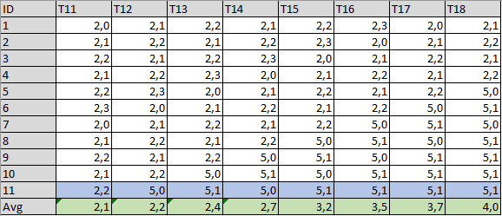

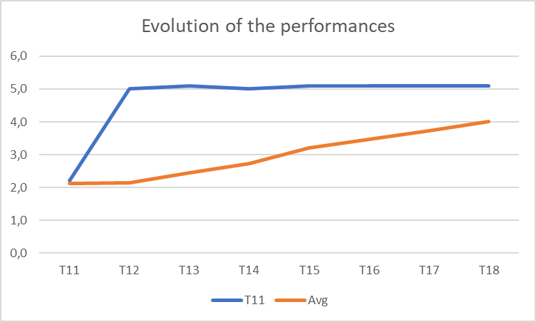

To quickly highlight the variation, we need to show on the same graph the average and the last measure.  
As you can see on the graph, at T12 we suddenly increase the elapsed time!

|  |
| --- |
| Performance with the Robot |

You can visualize the performances of a scenario in the Dashboard.

At the upper left, you can see an icon with a graph, each click will display a different graph.

|  |  |
| --- | --- |
|  | Graph of the execution of the story (status) |
|  | Graph of the performance of all the scenarios of the story |
|  | Graph of the performance of all the scenarios of a specific step of a story |

Note 1: The step is a kind of zoom on the graph to highlight specific scenarios.

Note 2: In the Dashboard, the Robot can use the value ‘Environment’ of the reference data.  
Be sure that you have defined the correct environment before displaying the performance!  
If no reference ‘Environment’ can be found, you will not be able to select the performance graph!

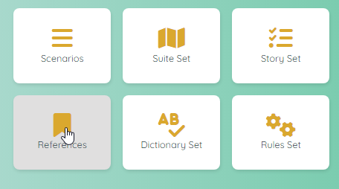

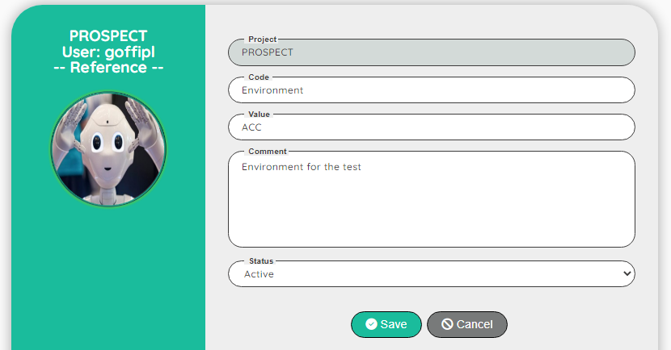

Note 3: In the Dashboard, the Robot can use the value ‘AllEnvironments’ of the reference data.  
If the reference doesn’t exist, there is no error, but the list will be limited to the current environment.

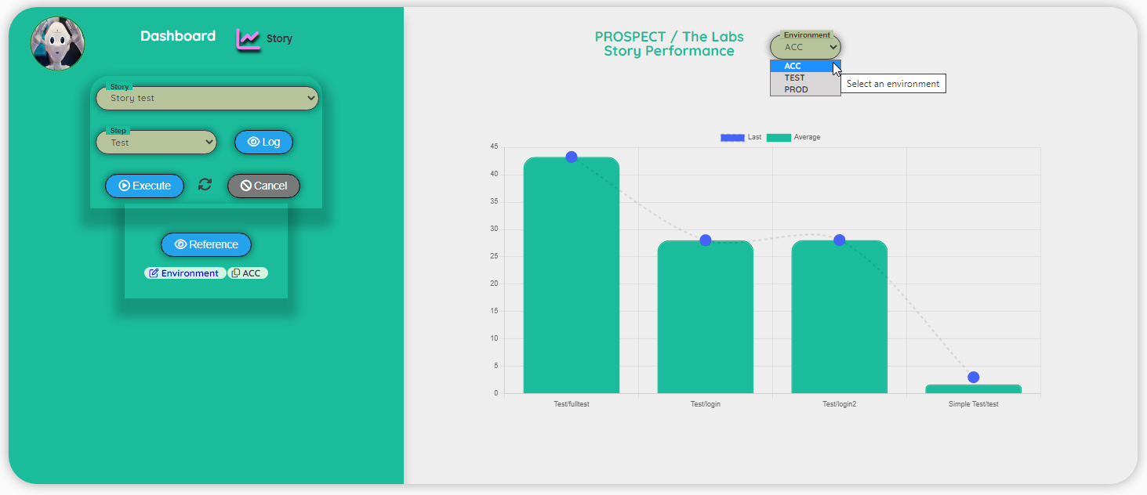



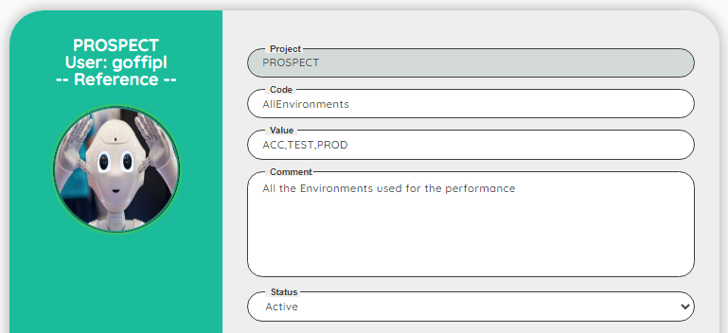

**Example: Performance of the story**

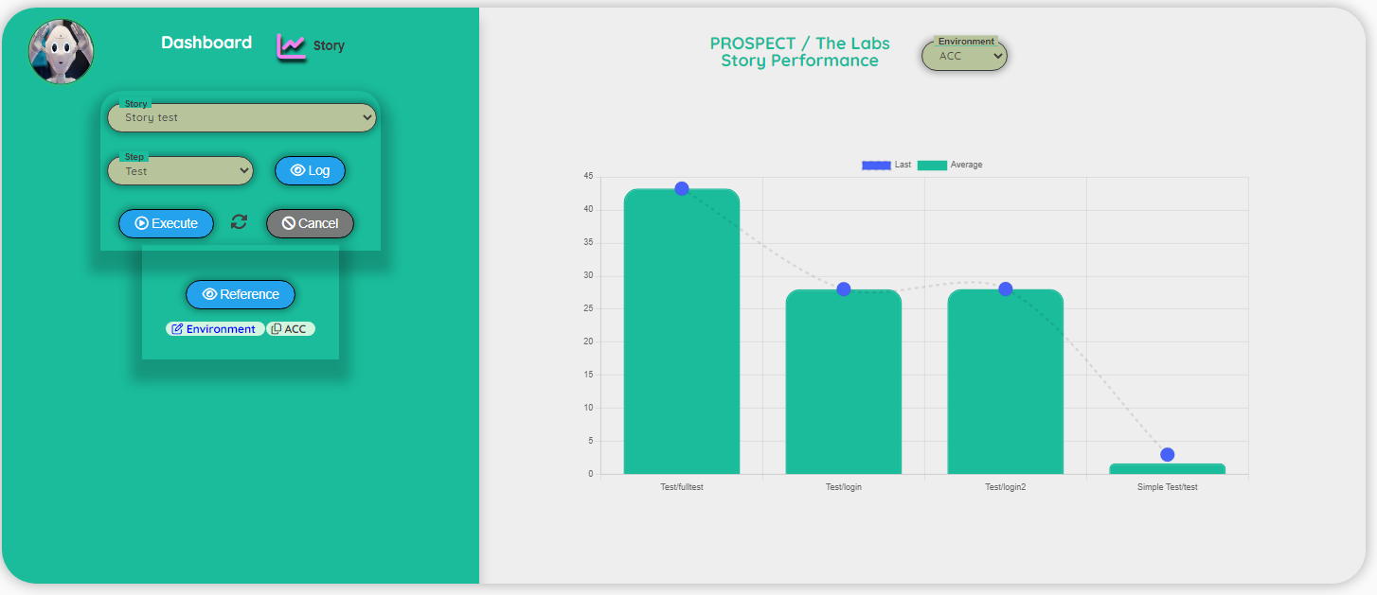

At this point the selection of a specific step has no impact on the graph.  
The first three bars represent the step: ‘Test’ and the last one, the step: ‘Simple’.

**Example: Performance of the step.**

In this case, we decided to highlight the step: Simple to have a better view of the gap between the average and the last measure.  
The step graph will act as a zoom.

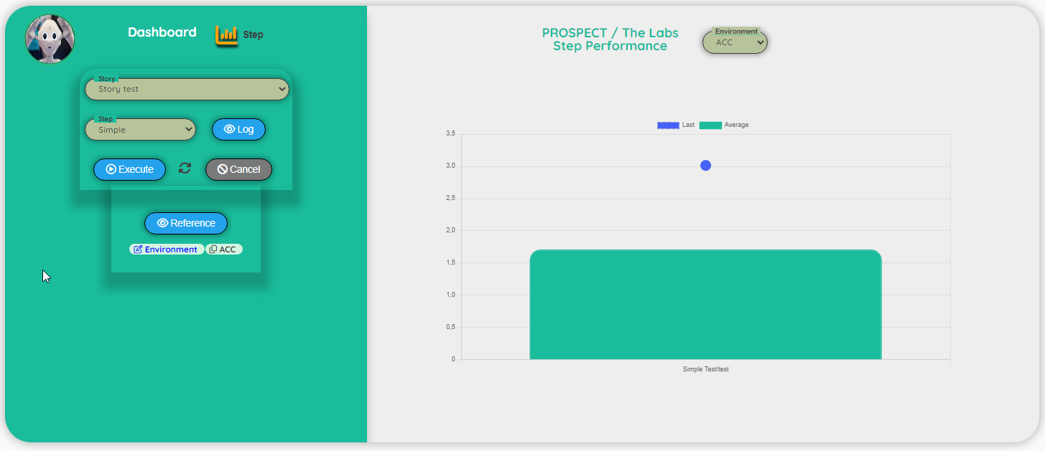

**Example: Performance detail (story or step).**

This graph is useful to view the variance of the measures.  
As we use up to 10 measures to compute the average, it’s also important to check the coherence of the measures. Although, the quality of the average will be better if you have already run the test a few time.

From 1 to 10 (in green), the data that will be used for the computation of the average.  
In blue the last measure recorded.

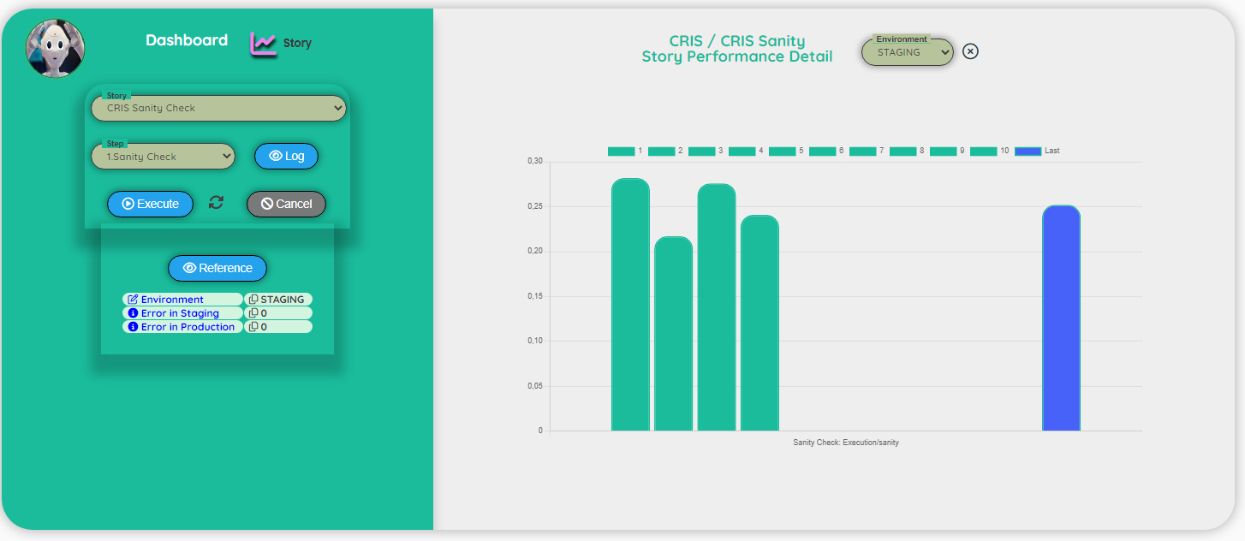

You can change the environment to get a quick comparison of the performances.

In this case the performances in PROD

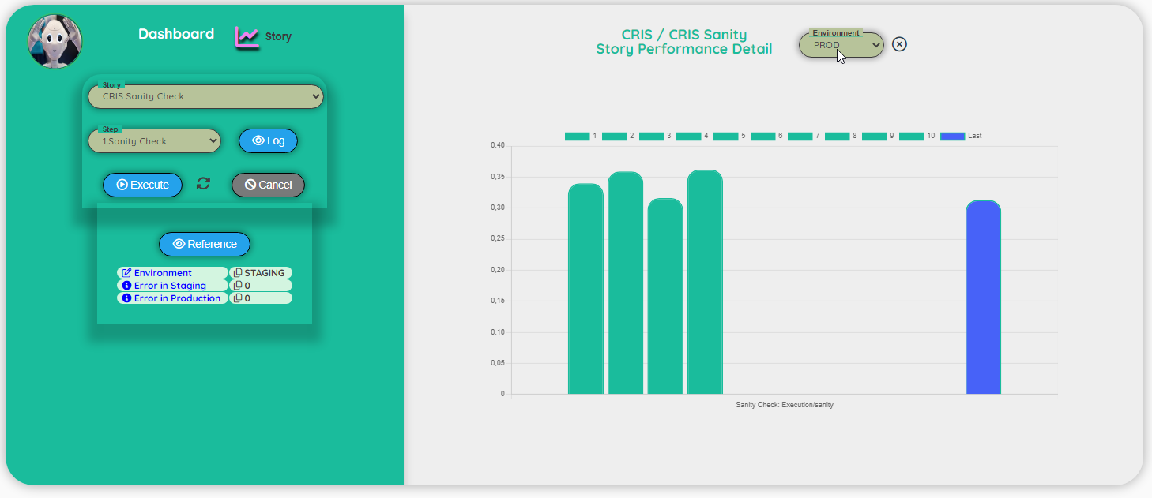

|  |
| --- |
| Performance with Admin right |

If you are connected to the application as Admin, you can export the performance data into a json file.

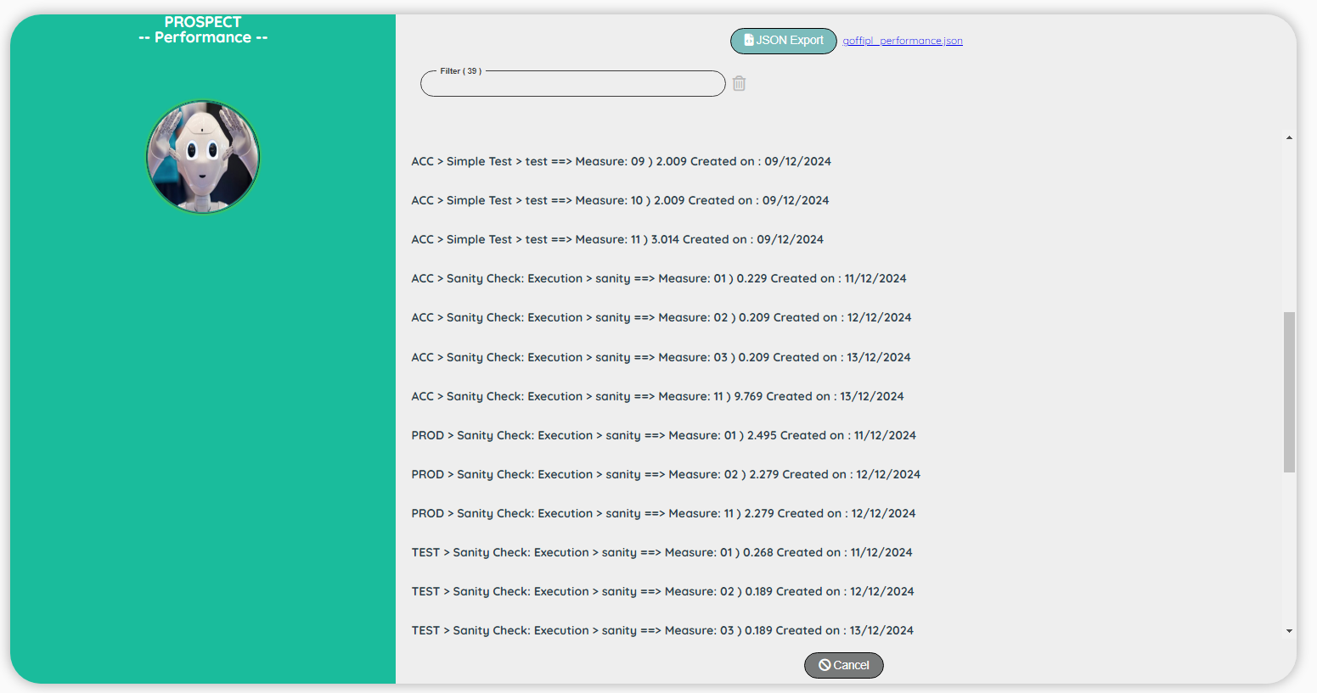

### The .json file has the following structure. You can see how to import a .json file into Excel in the Chapter: Test / How to process the .json file into Excel

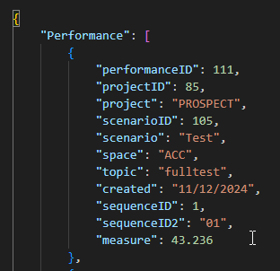

|  |
| --- |
| Example of graphs of performance designed in Excel |

This was designed for a previous project to show the evolution of the performances in the different business categories.

